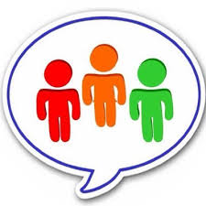  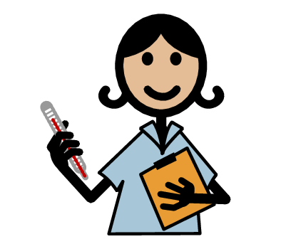 | My name i  I am ….
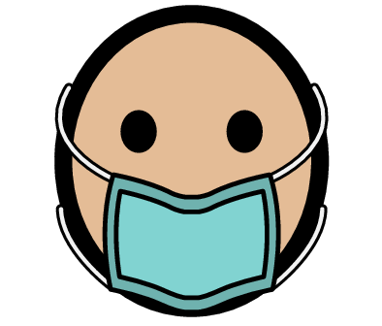 | I have to wear a mask  This mask keeps me safe so that I can look after you
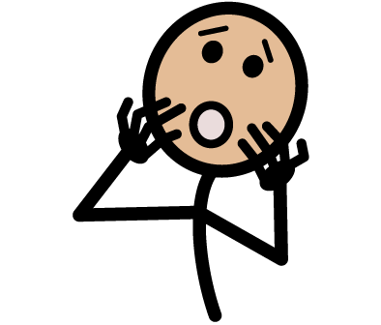 | You may think the mask looks scary
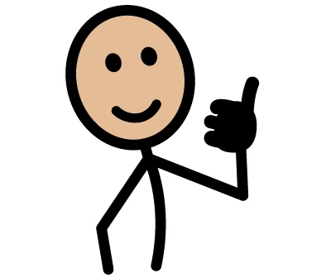 | It is ok to be scared of the mask
(stick photo with mask here) | This is what I look like with a mask on
(stick photo without mask here) | This is what I look like with no mask on

