Communication and wearing PPE
So we have an extra barrier to effective communication when we are wearing PPE. How this impacts on the person you are supporting and how you communicate will vary.
We know that for everyone in the population PPE affects communication
- How easily and clearly speech can be heard – so the person not understanding what you need to do, not understanding and explanation, not understanding what is going to happen next. Many people with LD have hearing impairment so this will make it even harder. Also not being able to see someone’s mouth when they are talking can affect communication, especially when you have a hearing impairment.
- Not being able to see the person’s face to know who is supporting you
- Hader to read people’s emotions when you can’t see their face. Even though we understand a lot of facial expression around emotions by just looking at the eyes not everyone can do this well, especially people with ASD.
- It may increase the focus on eye contact which some people with ASD struggle with
- It will influence communication in a general sense and we will need to adapt out communication approaches, people with communication difficulties will need further adaptations
- Much harder to engage in nonverbally based interaction approaches such as Intensive Interaction

Here are some ideas, many of which will come naturally to you. By all means contact SLT if there is a particular communication issue we could help you with.

Ideas to support with this
- Photos and stickers are being used within acute hospitals on top of gowns with “hello my name is….”
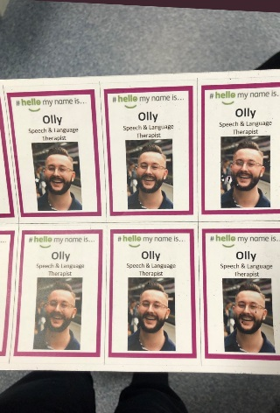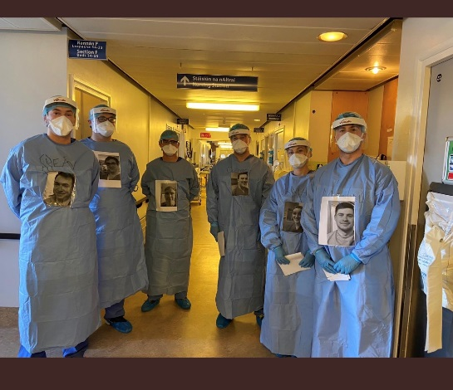
examples taken from Twitter #HelloMyNameIs

Even more important to say who you are when you support someone when you are wearing a mask.

- You could talk ever so slightly slower and slightly louder – but don’t shout or use a head bobbing gesture
- Tell them how you are feeling as they might not be able tell
- Use more exaggerated well understood gestures –
- a ‘thumbs up’ or double thumbs up goes a long way to reassure and convey things are good
- a ‘clap’ gesture to say things are going well is reassuring
- a ‘wave’ of course upon greeting someone
- demonstrate what you need people to do by gesture and modelling the action
- A reassuring touch on the arm may still be possible. A touch to the arm is less sensitive and less intrusive than a hand hold. But you still may be able to hold someone’s hand with PPE if it helps reassure the person
- Point to things to show people what you mean before you do anything
- Bush up on your signing skills and use them if the person you work with understands them
- You can back up what you are saying by showing photos and symbols and written words which will help with understanding what you say. This can also be a focus for interaction people who may not like such direct eye contact that the masks may lead to.
Some acute hospital staff have some lovely pocket sized key messages ready see this for an example and resources. We can of course help you create the cards for what you want to say in your place of work
http://www.aphasiafriendly.co/covid-19-accessible-information.html
- Remember as it can be more difficult to hear people speak with a mask on so where possible reduce background noise e.g. turn radio down before you talk to them

- To help people understand about PPE there are many easy read examples on the internet. Choose which one you think will help the person you are supporting best.
https://www.keepsafe.org.uk/resources/why-we-wear-ppe-poster

If you need our help or any other resources with communicating with someone with COVID please do contact us and we will work it out together.
ALD and MH Speech and Langauge Therapy Service

Advice on intensive interaction from Graham Firth of the Intensive Interaction Institute webpages
It may be necessary to use Intensive Interaction strategies that can be enacted with more and therefore safer social distance e.g.:
Using more demonstrative body language e.g. using bigger hand gesturing or using more dramatised body posture, or shoulder movements, to communicate our social responsiveness.
Finding more ways to exchange eye contacts and mirror facial signalling (from a safe social distance) e.g. using more dynamic, or even very dramatised eye-brow expressions and head movements from further away.
Using more, or more kinds of behavioural mirroring (at a safe social distance), including amplified hand, arm or body movements to make our socially interactive responses clearer for the person to see or sense.
Developing increased turn-taking in various forms (from a safe social distance) e.g. via sequenced hand, arm or body movements; clapping hands or tapping feet in sequence or together; tapping or banging items of furniture in sequence or together; using a range of sequenced voice or mouth sounds.
Using standard vocal echoing or exchanges of vocal/verbal sequences (at a safe social distance): remember, responding to a person’s vocalisations does not have to be via a direct echoing; some physical movement can also act as an appropriate response, so long as the shape of the movement somehow matches the pattern of the person’s vocalisation.
Using verbal “commentaries” on a person's actions, or the actions of others in a shared environment; possibly at increased volume from a safe distance.
Using more forms of ‘joint-focus’ activity that can be enacted with greater social distancing e.g. jointly listening to music or watching mutually interesting TV or films together, and regularly signalling the mutual enjoyment of the joint activity with the person e.g. via frequent eye contact and shared smiles.
Also, while Intensive Interaction is a mainly responsive approach, due to social distancing then more proactive social initiation by a practitioner choosing the safest, socially distant means, seems entirely prudent and correct i.e. proactively using the safest interactive means available (taken from any previously developed interactive repertoire with a person) will often be the most advisable. Trialling different ‘safer’ interactive means will at times be necessary; some adaptations will work well, others may not – that is just the nature of Intensive Interaction anyway!

